Indian Presidential Election Prediction Model

Chris Paul,

Department of Electronics & Telecommunication,

Sardar Patel Institute of Technology,

Mumbai, India

[chris.paul@spit.ac.in](mailto:chris.paul@spit.ac.in)

***Abstract – The President of India is indirectly elected by an Electoral College consisting of the elected members of both houses of parliament, the elected members of the Legislative assemblies of the 28 states, and the elected members of the legislative assemblies of the Union Territories of Delhi, Puducherry and Jammu and Kashmir. Experimental results show that the proposed Prediction Model can show the value of votes of elected Members of the Legislative Assemblies, Members of Parliament from each state & party in the Electoral College.***

***Keywords – Electoral College, Members of the Legislative Assemblies (MLAs), Members of Parliament (MPs), States, Union Territories (UTs), Political Parties, MATLAB, Microsoft Excel***

1. **INTRODUCTION**

The president of India, known officially as the president of the Republic of India, is the head of state of the Republic of India.

Article 58 of the constitution sets the qualifications one must meet to be eligible for the office of the president. A president must be:

* a citizen of India
* of 35 years of age or above
* qualified to become a member of the Lok Sabha.

The president is indirectly elected by an electoral college comprising both houses of the Parliament of India and the legislative assemblies of each of India's states and territories, who themselves are all directly elected.

The presidential electoral college is made up of the following:

* elected members of the Rajya Sabha (upper house of the Parliament of India);
* elected members of the Lok Sabha (lower house of the Parliament of India);
* elected members of each state's Legislative Assembly (lower house of the state legislature); and
* elected members of each union territory possessing a Legislative assembly (i.e. Delhi, (Jammu & Kashmir not included) and Puducherry, etc.)

The value of votes cast by elected members of the state legislative assemblies and both houses of parliament are determined by the provisions of Article 55(2) of the Constitution of India. Per the 84th Amendment, the 1971 census is used and will continue to be used until 2026.

The formula for determining the number of votes held by an MLA is:

$Value of an MLA vote=\frac{x}{1000×y} (1)$

Where: x = Total population of the state or union territory according to 1971 census & y = Total number of elected members of the State legislative assembly

The value of an MP's vote is calculated by dividing the total value of all MLAs' votes by the number of MPs. The formula for determining the number of votes held by an MP is:

$Value of an MP vote=\frac{a}{b} (2)$

Where: a = The sum of vote value of elected members of all the State Legislative Assemblies & b = The sum of elected members of both the Houses of Parliament.

The program for the Prediction Model is written using the (1) & (2). In the following sections, Section II introduces the proposed Prediction Model in detail. Section III presents the experimental results of the working Model & shows the output of the program. Section IV will deal with applications of the Prediction Model. Finally, conclusions are drawn in Section V.

1. **PROPOSED PREDICTION MODEL**

The proposed Prediction Model program could have been written in C++, Java, or Python, but instead was written in MATLAB. The reason for writing this program in MATLAB is that the necessary commands & function generation are accessible in MATLAB, and MATLAB's programming language is simple.

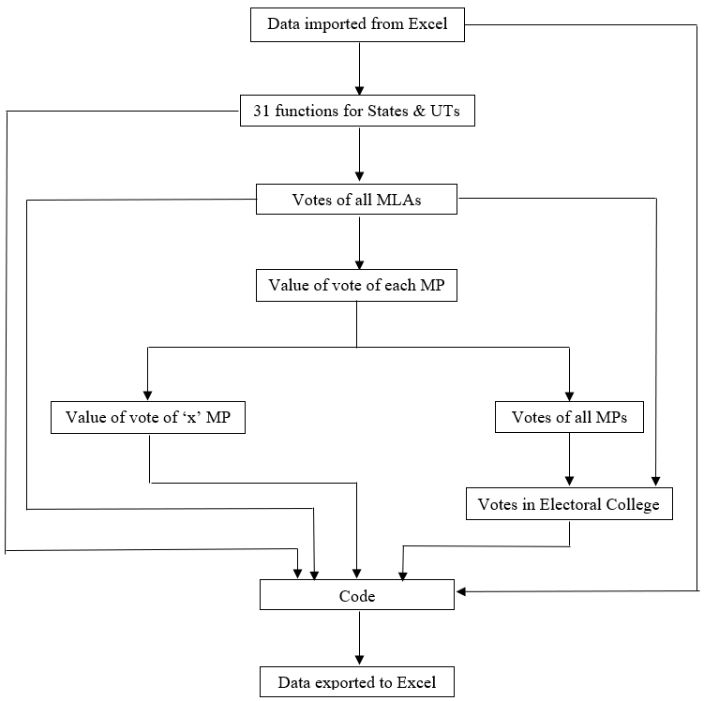

Figure 1 – Flowchart of the Model

Figure 1 shows the Flowchart of the entire Prediction Model. The entire Data of MLAs & MPs in each state & union territory & of each political party are mentioned in the Database Microsoft Excel File. The population of every state & union territory according to the 1971 Census is also mentioned in this Excel File. This Excel File not only contains the 1971 Census but also contains the 2011 Census & 2022 Estimate Population. This Excel File is editable to the user & the data here can be changed easily making the input data of the Prediction Model dynamic.

The data from Excel first goes to 31 different functions named after every 28 states, Delhi, Puducherry, and Jammu and Kashmir. These 31 functions return the value of the number of MLAs votes in each state using the first formula. The number of MLA has to be given as input to the function.

The total number of elected MLAs in each state is given to respective functions in the “Value of all MLAs votes” function. This function returns the value of all the MLA votes in the Electoral College which is 5,49,495.

The value of all MLA votes in the Electoral College is used to calculate the value of each MP using the second formula which is 708 in “Value of each MP’s vote” function. This value is sent in two places – “Value of ‘x’ number of MPs vote” function & “Value of all MPs vote” function.

The “Value of ‘x’ number of MPs vote” function is used to calculate the value of votes of a certain number of MPs votes. The “Value of all MPs vote” function imports the number of elected MPs to calculate the value of total MPs vote in the Electoral College which is 5,49,408.

The values from the “Value of all MLAs votes” & “Value of all MPs vote” functions are added to calculate the entire value of the Electoral College which is 10,98,903 votes in the “All Votes” function.

This is how the 36 functions of the Model is written – 31 for states & union territories, 5 for “Value of all MLAs votes”, “Value of each MP’s vote”, “Value of ‘x’ number of MPs vote”, “Value of all MPs vote” & “All Votes” functions. All these 36 functions are used in the code. The data from Excel is also imported to the code.

The code is divided into two slave codes & one Master code – the first slave code deals with the results according to states & union territories & the second slave code deals with the results according to political parties. These two slave codes are run using a Master code which will be only been seen to the user. This Master code has only two lines of code which are run commands for the two main codes. The four tables that are formed using the Model are then exported to another Microsoft Excel File named “Result”.

1. **EXPERIMENTAL RESULTS**

The output which is presented in this paper is using the data as of 23rd March 2022.



Figure 2 – Total MLA Vote Share in Electoral College



Figure 3 – Total MP Vote Share in Electoral College



Figure 4 – Total Electoral College Vote Share according to Alliance



Figure 5 – Total Electoral College Vote Share according to States & Union Territories



Figure 6 – Total Electoral College Vote Share according to Parties

PDF 1 – Tabular Output of the Model (Attached at the end of the Paper)

The above figures & PDF shows the proposed Prediction Model. Figure 2 shows the Total MLA Vote Share in Electoral College. It shows that National Democratic Alliance (NDA) has 40% of the MLA vote share in the Electoral College while United Progressive Alliance (UPA) has 30% & Others have 30% of the MLA vote share in the Electoral College.

Figure 3 shows the Total MP Vote Share in Electoral College. It shows that NDA has 58% of the MP vote share in the Electoral College while UPA has 19% & Others have 23% of the MP vote share in the Electoral College.

Figure 4 shows the Total Electoral College Vote Share according to Alliance. It shows that NDA has 49% of the vote share in the Electoral College while UPA has 24% & Others have 27% of the vote share in the Electoral College. This indicates that even though NDA has a majority, they don’t have the required majority to win the Presidential Election of 2022 without the support of Other parties who are currently not member parties of UPA.

Figure 5 shows the Total Electoral College Vote Share according to states & union territories. The Pie Chart can be used with the support of Table 3 which also shows the same data but in tabular format which is more readable here.

Figure 6 shows the Total Electoral College Vote Share according to Parties. The Pie Chart is not clear and the reason for the same is that the Electoral College currently consists of 98 Parties. The Pie Chart can be better be understood using Table 4 in the PDF attached below. It shows the percentage share of each political party in the Electoral College. Using Table 4, we can determine who can help NDA to acquire the required majority & see that if a united front of UPA & Other parties is made, it could lead to the President of their choice.

There are more three tables in the output. The first table (Table 1) is MLAs' vote status in Electoral College according to Alliances. This table shows the MLA vote status of each state & union territory in the Electoral College according to Alliances. The second table (Table 2) is MPs' vote status in Electoral College according to Alliances. This table shows the MP vote status of each state & union territory in the Electoral College according to Alliances.

1. **APPLICATIONS**

Indian Presidential Election Prediction Model, presented in this paper is very useful during every Presidential Election not only in 2022 but also the future elections as the input data could be easily changed in the Microsoft Excel file. The output of this Model is in Graphical & Tabular formats which could help the user to analyze the situation of the Electoral College & could be used to form alliances. The 1971 Census will be used till 2026 according to 84th Amendment. This model could be used to see the status of the Vote Share of each state & union territory in the Electoral College using the 2011 Census & 2022 Estimate Population as the base population.

1. **CONCLUSION**

Experimental results indicate that the proposed model has significant usage in predicting in graphical as well as tabular format, the status of the Electoral College according to alliances, states & parties. One of the drawbacks of the purposed model in this paper is that MATLAB takes 2 and half minutes to execute the code as there are 992 codes to be executed with data to be imported from & exported to different Microsoft Excel sheets. Another drawback is that to execute the code, MATLAB is required. The future development of this project would be making this project a Standalone Project which won’t require MATLAB to execute the project.

**Acknowledgment**

This work would not have been possible without the help of the Department of Electronics & Telecommunication, Sardar Patel Institute of Technology, Mumbai, India.

**Bibliography**

1. ["Election to the Office of President of India 2017" by Election Commission of India](https://ceodelhi.gov.in/eLearningv2/admin/HindiPDF/President_Election_08062017.pdf)
2. <https://www.youtube.com/watch?v=7phsyzyqttE>
3. <https://en.wikipedia.org/wiki/President_of_India#Time_of_election>
4. <https://en.wikipedia.org/wiki/2022_Indian_presidential_election>
5. <https://en.wikipedia.org/wiki/Electoral_College_(India)>
6. <https://www.indiatoday.in/diu/story/presidential-polls-beyond-why-uttar-pradesh-elections-are-crucial-1831194-2021-07-22>